**Developing New Multivariate Process Capability Indices for Non-Normal Data**

J.N. Pan*

*Department of Statistics, National Cheng Kung University, Tainan, Taiwan, 70101, ROC*

C.I. Li

*Department of Applied Mathematics, National Chiayi University, Chiayi, Taiwan* 60004*, ROC*

W.C. Shih

*Department of Statistics, National Cheng Kung University, Tainan, Taiwan, 70101, ROC*

Generally, an industrial product has more than one quality characteristic. In order to establish performance measures for evaluating the capability of a multivariate manufacturing process, several multivariate process capability indices have been developed based on the assumption of normality. Quality characteristics of many manufacturing processes in the chemical, pharmaceutical and electronic industries, however, often do not follow normal distribution. This paper develops two non-normal multivariate process capability indices, *RNMCp* and *RNMCpm* that relax the normality assumption. Using the two normal multivariate process capability indices proposed by Pan and Lee, a multivariate weighted standard deviation method (MWSD) is used to modify the *NMCp* and *NMCpm* indices for the nominal case. Then the MWSD method is applied to modify the multivariate process capability index established by Niverthi and Dey, the ND index, for the-smaller-the-better case.

A simulation study compares the performance of the various multivariate indices. Simulation results show that the actual non-conforming rates can be correctly reflected by the proposed indices, which are more appropriate than the previous *MCp*, *MCpm*, *NMCp*, *NMCpm* and the *ND* indices for a non-normal distribution. Two skewed distributions were used in various configurations. The proposed capability indices can thus be applied to the performance evaluation of multivariate processes subject to non-normal distributions.

**Keywords:** Multivariate process capability indices; Non-normal distributions; The-nominal-the-best case; The-smaller-the-better case

**1. Introduction**

Generally, an industrial product has more than one quality characteristic. In order to establish performance measures for evaluating the capability of multivariate manufacturing processes, several multivariate process capability indices have been developed based on the assumption of normality in the past two decades (see [1], [2], [3], [4] for details). However, the quality characteristics of many manufacturing processes in the chemical, pharmaceutical and electronic industries, process data may not follow normal distribution. If the non-normal process data is mistreated as a normal one, it will result in an improper decision and thereby lead to an unnecessary quality loss. Therefore, the purpose of this research is to develop new multivariate process capability indices to relieve the normality assumption for two common types of quality characteristics, i.e. the-nominal-the-best and the-smaller-the-better cases.

In addition, though process capability indices have been widely applied in evaluating the quality performance of manufacturing processes, they are seldom applied to the evaluation of environmental performance, especially for non-normal data. With the advent of high-technology, the problems of the air, water and land pollution have led to widespread environmental contamination. To prevent further deterioration of the environmental system many organizations and corporations around the world are beginning to review their environmental performance as stipulated by their respective Environmental Protection Agencies. Thus, a method for monitoring environmental performance becomes an important research issue. According to Corbett [5], the process capability indices for the-smaller-the-better case, which measure the degree to which the process is capable of remaining below the existing regulatory limits, can be used as a measure of the environmental quality of a process. Most environmental processes, however, have at least one quality characteristic that exhibits a non-normal distribution especially for the-smaller-the-better case. This paper develops two non-normal multivariate process capability indices, RNMCp and RNMCpm that relax the normality assumption. Using the two normal multivariate process capability indices proposed by Pan [1], a multivariate weighted standard deviation method (MWSD) is used to modify the NMCp and NMCpm indices for the non-nominal case. Then the MWSD method is applied to modify the multivariate process capability index established by Niverthi [2], the ND index, for the-smaller-the-better case.

The objectives and structure of this paper are stated as follows:

1. To develop non-normal multivariate process capability indices, which properly reflect the actual non-conforming rate, for both the-nominal-the-best and the-smaller-the-better cases.
2. To conduct simulation studies to compare the performance of the proposed non-normal multivariate capability indices with the previous ones under different combinations of a right skewed and left skewed distribution.
3. To demonstrate that the indices can be used in practical applications.

**2.　Literature review**

***2.1.　Univariate process capability indices***

Process capability indices have been widely used in industry to provide quantitative measures of process performance that lead to quality improvement. The most commonly used process capability indices are:

 (1)

 (2)

 (3)

 (4)

where is the process average,σ is the process standard deviation, *USL* is upper specification limit, *LSL* is lower specification limit and *T* is the target value.

Juran [6] proposed the *Cp* index. It considers the ratio of the engineering tolerance to the natural tolerance and reflects only the process precision. The *Cpk* index proposed by Kane [7] considers both the process precision and the process accuracy. Considering the loss function approach, the *Cpm* index proposed by Chan [8] adds an additional penalty for process shift, that is, as the mean drifts away from the target. Pearn [9] proposed *Cpmk* index which is more sensitive to the actual performance of the population than *Cp*,*Cpk* or *Cpm* as the process mean deviates from the target.

For the cases with skewed distributions or two-sided specification limits, Wu [10] introduced a new process capability index based on weighted variance. This method divides a skewed distribution into two normal distributions from its mean to create two new distributions with the same mean, but different standard deviations. Chang [11] proposed a different method for constructing simple process capability indices with skewed populations based on a weighted standard deviation (WSD) method. Their method uses the standard deviation of the quality characteristic divided into upper and lower partitions representing the degree of dispersion of these partitions from the mean. Their indices are defined as:



(5)

 $C_{pk}^{WSD}=\min\left\{\frac{USL-μ_{x}}{6P_{x}σ_{x}},\frac{μ_{x}-LSL}{6\left(1-P_{x}\right)σ_{x}}\right\},$ (6)

where *Px* is the probability of the quality characteristic being less than or equal to the mean. If the underlying distribution is symmetric, then, i.e.  and . Some properties for the indices in (5) and (6) have been investigated by Chang [11] with their estimators compared to other methods that also use non-normal data.

***2.2　Multivariate process capability indices***

Taam [4] proposed two multivariate process indices *MCp* and *MCpm*. Their multivariate process capability index *MCpm* is defined as the ratio of two volumes,

, (7)

where *R*1 is a modified engineering tolerance region and *R2* is a scaled 99.73% process region, which is an elliptical region if the underlying process distribution is assumed to be multivariate normal. Moreover, the modified engineering tolerance region is the largest ellipsoid that is centered at the target and falls within the original engineering tolerance region. Thus, the *MCpm*. index can be rewritten as *MCpm*=*MCp*/*D* where  is a correcting factor if the process mean **μ** is deviated from the target **T** with **Σ** as the covariance matrix. The  index represents the ratio of a modified tolerance region with respect to the process variability as written in Equation (8)

, (8)

where , ,  is the notation used for the determinant and where  is a Gamma function. Niverthi and Dey [2] proposed an extension to the univariate *Cp*, *Cpk* indices for the multivariate case. Their index is a linear combination of the upper and lower specifications limits of the *v* variables and is defined as

,

where ***USL*** = (*USL*1, …,*USL*v)T and ***LSL*** = (*LSL*1, …,*LSL*v)T, **μ** is the mean vectorand **Σ** is the variance-covariance matrix. In this case, a capability value is generated for each quality characteristic, where (*v*x1) are dimensional vectors. The estimator of index can be written as:

,

where  is the sample mean vector and  is the sample variance -covariance matrix.

Pan and Lee [1] claimed that the multivariate process capability indices *MCp* and *MCpm* proposed by Taam [4] may overestimate the true process performance in certain situations, when the quality characteristics are not independent. Considering the correlation among key characteristics, they revised the modified engineering tolerance region by Taam [4]and proposed the index

 ,

where *NMCp*=(|**A*|**/|**Σ|**)1/2, . The elements of matrix **A** are given by

, *i*, *j* = 1,…,*v*,

where *v* is the number of quality characteristics, *ρ*ijrepresents the correlation coefficient between the *i*th and *j*th quality characteristics and (*USL*i − *LSL*i) denotes the specification width of the *i*th quality characteristics.

**3.　Developing A Non-Normal Multivariate Process Capability Index**

***3.1.　 Multivariate Weighted Standard Deviation Method***

Chang and Bai [12] extends the univariate WSD method to a multivariate control process by adjusting the variance covariance matrix with the WSDs of each quality characteristic. Thus, they propose a multivariate control chart for skewed populations. This research develops a non-normal multivariate process capability index based on their multivariate WSD method as follows:

Assume that a *v*-variant quality characteristics ***X***=(*X*1, …, *X*v)T is distributed with mean vector **μ** and variance-covariance matrix **Σ.** According toChang and Bai [12], the variance-covariance matrix can be adjusted as follows:

 , (9)

where

，,

，.

The multivariate WSD method approximates the original probability density function (PDF) with segments from 2*v* multivariate normal distributions. For example, when *v* = 2, the original PDF can be approximated by four bivariate normal distributions with the same mean **μ** but different variance-covariance matrices as follows:

 (10)

 (11)

 (12)

 (13)

***3.2.　Developing new non-normal multivariate process capability indices***

To develop the new non-normal multivariate process capability indices, the variance-covariance matrix is modified in the index *NMCp*=(|**A*|**/|**Σ|**)1/2 as proposed by Pan and Lee[1]. For the-nominal-the-best case, the *RNMCp* index is defined as

$${\left(\frac{\left|A^{*}\right|}{\left| Σ^{W} \right|}\right)}^{\frac{1}{2}},$$

where the adjusted variance-covariance matrix **Σw** is defined as in Equation (9).Since a variance-covariance matrix **Σ** can be approximated bya2*v* adjusted variance-covariance matrix **Σw**, the adjusted variance-covariance matrix with the largest determinant value should be considered. In this case, the *RNMCp* index provides a conservative measure of process performance by reflecting the worst scenario. Thus, the new non-normal multivariate process capability indices, *RNMCp,* can be written as:

 (14)

where is thematrix with the largest determinant value among 2*v* , the adjusted variance-covariance matrices. Similarly the *NMCpm* index, also proposed byPan and Lee [1], is modified so as to define  index as:

 (15)

where is the new correction factor which denotes a function of the Mahalanobis distance between the process mean **μ** and its target vector **T**.

For the smaller-the-better case, the index as proposed by Niverthi and Dey[2] is modified to the *RNMCpu* index such that:

,

where ***USL*** = (*USL*1, *USL*2)T, **μ** = (μ1**,** μ2)T and

. (16)

**4.　Comparative analysis of various multivariate process capability indices**

***4.1.　Introduction of two evaluation criteria***

The following two evaluation criteria are used to compare the performance of various multivariate process capability indices:

1. Assuming the overall non-conforming rate of a multivariate process is 0.27%, first the upper and lower specification limits (*USL*, *LSL*) are set. Then the mean of the index values in the simulation are compared to the performance of the other multivariate process capability indices (MPCIs) under non-normal distributions.
2. The Mean Squared Error, MSE, and Mean Absolute Percent Error, MAPE, listed in Equation (17) and (18), are used as the second criterion for evaluating the accuracy of the various MPCIs such that:



(17)

(18)

where  is the actual index value, is estimated value for index.

***4.2.　Summary of the comparison results for Criterion (1)***

5000 simulations were run of the various capability indices. Their performance is summarized in the tables and graphs below.

The simulation procedure is listed below：

1. Use copula functions to generate various bivariate Gamma distributions with different skewedness coefficients (α3) in which 0.5, 1.0, 1.5, 2.0, 2.5 corresponds to Gamma(16,4), Gamma(4,2), Gamma(1.778,1.333), Gamma(1.5625 , 1.25), Gamma(0.64 , 0.8) respectively. The sample size was n= 30, 50, 100 and 1000.
2. Use copula functions to generate various Beta-Gamma combined distributions (with one left-skewed and the other right-skewed) by taking random samples with sample sizes: n= 30, 50, 100 and 1000. The five skewedness coefficients (α3) considered are -0.5,-1.0,-1.5,-2.0, and -2.5, which correspond to the following five “left skewed” Beta distributions: Beta(8, 7.19), Beta(8, 1.6), Beta(8 , 0.923), Beta(8 , 0.586) and Beta(8 , 0.401). The five “right skewed” distributions are indicated in 1(a).
3. Assuming that the overall non-conforming rate of a multivariate process =

0.27%, first it’s the *USL* and *LSL* are set. Then the sampling information above is used to calculate an estimate for *MC*p, *NMCp*, and *RNMCp* as well as *MCpm*, *NMCpm*, and *RNMCpm* indices with three different target values



(19)

1. Use this simulation method to obtain the actual non-conforming rates (*p*) for the

cases shown in Table1, Figure2, Figure 3, Figure4 and Figure5.

Then, an estimate of their corresponding index values was made.

1. Summarize the simulation results in different tables and graphs to compare the

various Multivariate Process Capability Indices.

Compared with the other two indices, Table1 indicates that *RNMCp* index outperforms the other multivariate indices since it is much closer to the actual index values for the corresponing non-conforming rate *p* under different sample sizes and bivariate Gamma distributions. Note that the larger skewedness coefficient of a Gamma or Beta distribution, the greater actual non-conforming rate *p* will be, where α3 is the skewedness coefficient.

Table 1. Comparison of simulation results for various indices using different sample sizes, under the bivariate Gamma distribution with correlation coefficient =0.1

|  |  |  |  |  |  |  |  |  |  |
| --- | --- | --- | --- | --- | --- | --- | --- | --- | --- |
|  |  |  | Actual | n=100 | | | n=1000 | | |
| Distribution | α3 | p | Indices for p |  |  |  |  |  |  |
|  | (0.5,0.5) | 0.6478% | 0.852 | 0.888 | 1.035 | 1.029 | 0.883 | 1.016 | 1.007 |
|  | (0.5,1.0) | 1.0065% | 0.778 | 0.845 | 1.031 | 1.024 | 0.830 | 1.013 | 1.004 |
|  | (0.5,1.5) | 1.3662% | 0.726 | 0.803 | 1.032 | 1.026 | 0.782 | 1.012 | 1.003 |
|  | (0.5,2.0) | 1.4354% | 0.718 | 0.797 | 1.037 | 1.031 | 0.776 | 1.012 | 1.003 |
|  | (0.5,2.5) | 1.9119% | 0.669 | 0.743 | 1.055 | 1.049 | 0.711 | 1.010 | 1.002 |
|  | (1.0,1.0) | 1.3511% | 0.728 | 0.806 | 1.033 | 1.027 | 0.780 | 1.012 | 1.003 |
| bivariate | (1.0,1.5) | 1.7039% | 0.689 | 0.767 | 1.042 | 1.035 | 0.739 | 1.010 | 1.002 |
| Gamma | (1.0,2.0) | 1.7695% | 0.682 | 0.757 | 1.029 | 1.023 | 0.729 | 1.009 | 1.001 |
|  | (1.0,2.5) | 2.2397% | 0.642 | 0.713 | 1.061 | 1.055 | 0.670 | 1.012 | 1.006 |
|  | (1.5,1.5) | 2.0510% | 0.657 | 0.735 | 1.043 | 1.037 | 0.698 | 1.010 | 1.002 |
|  | (1.5,2.0) | 2.1123% | 0.652 | 0.727 | 1.048 | 1.042 | 0.690 | 1.010 | 1.002 |
|  | (1.5,2.5) | 2.5722% | 0.619 | 0.682 | 1.063 | 1.058 | 0.632 | 1.011 | 1.005 |
|  | (2.0,2.0) | 2.1784% | 0.647 | 0.717 | 1.055 | 1.049 | 0.684 | 1.010 | 1.003 |
|  | (2.0,2.5) | 2.6347% | 0.615 | 0.670 | 1.072 | 1.067 | 0.625 | 1.011 | 1.005 |
|  | (2.5,2.5) | 3.0857% | 0.588 | 0.640 | 1.084 | 1.078 | 0.576 | 1.014 | 1.009 |

To illustrate the relationship between *RNMCp* and the correlation coefficients using with different non-conforming rates, 1000 bivariate samples for both bivariate distributions were generated combined Gamma-Beta with correlation coefficients equal to 0.1, 0.3, 0.5, and 0.7. Figure1 (a) and (b) show that there is no correlation between the *RNMCp* indices and the correlation coefficients regardless of combined Gamma-Beta the distribution.

Thus, in Table1,one can set the correlation coefficient to 0.1 without a loss in generality. In addition, *RNMCp* values decrease as the non-conforming rate increases. Note that both the *MCp* and *NMCp* fail to reflect this trend (see Table1 for details).

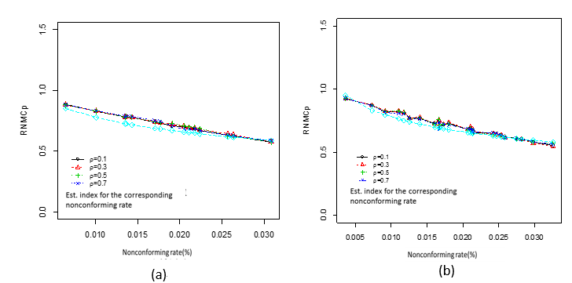

Figure 1. Relationship between *RNMCp* index and various correlation coefficients under different non-conforming rates for two distributions (a) Bivariate Gamma and (b) Combined Gamma-Beta .

Assuming that the overall non-conforming rate is fixed at 0.27%, the condition when the process means hit the target values is considered. Figure 2 and 3 compare the performance of various multivariate indices in terms of properly reflection of the actual non-conforming rates for both bivariate Gamma and combined Gamma-Beta distributions. The blue lines of the actual indices in the above figures show the decreasing trend as the actual non-conforming rate increases. Note that only *RNMCp* (see black lines in Figure 2 and 3) reflect this trend while the *MCp* and *NMCp* indices fail to reflect this trend. Similarly, considering the condition when one process mean is greater than the target value and the other process mean is less than the target value, Figure 4 and 5 compare the performance of various multivariate indices (*MCpm*、*NMCpm* and *RNMCpm*). This accurately reflects the actual non-conforming rates for both bivariate Gamma and combined Gamma-Beta distributions. Note that only the *RNMCpm* index can correctly reflect the decreasing trend of the actual non-conforming rate.

Moreover, Figure 2, 3, 4, and 5 show that the gaps between *RNMCp, RNMCpm* and actual indices for the corresponding non-conforming rate are getting smaller as the sample size increases. Therefore, the actual non-conforming rates for the non-normal data can be properly reflected by the proposed *RNMCp*, *NMCpm* indices regardless of the process mean hitting the target or not.

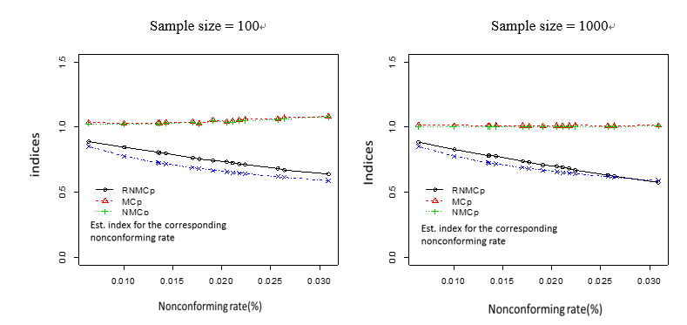

Figure 2. Comparison of simulation results for various *MPCp* indices under Bivariate Gamma distributions (when sample size n=100 and 1000) 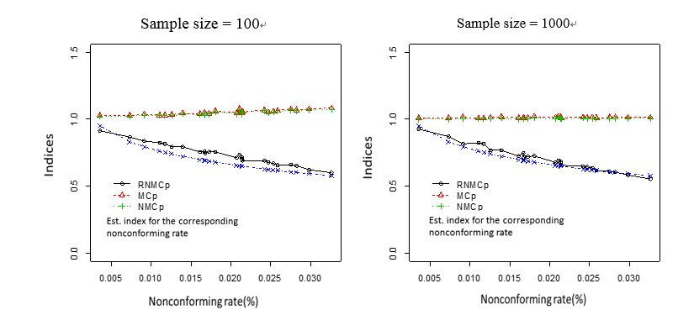

Figure 3. Comparison of simulation results for various *MPCp* indices under Combined Gamma-Beta distributions (when sample size n=100 and 1000)

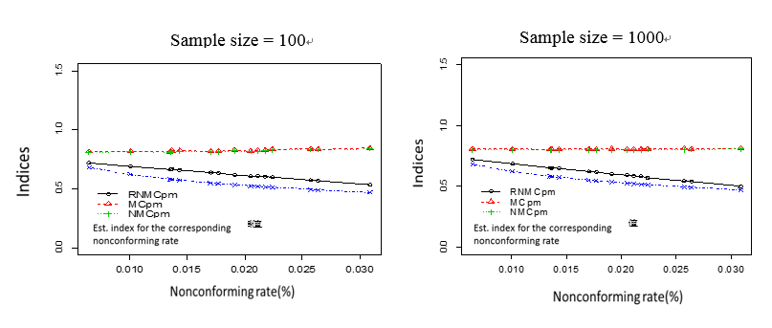

Figure 4.Comparison of simulation results for various *MPCpm* indices with different non-conforming rates under the Bivariate Gamma distributions (when one process mean > target value, the other process mean < target value) 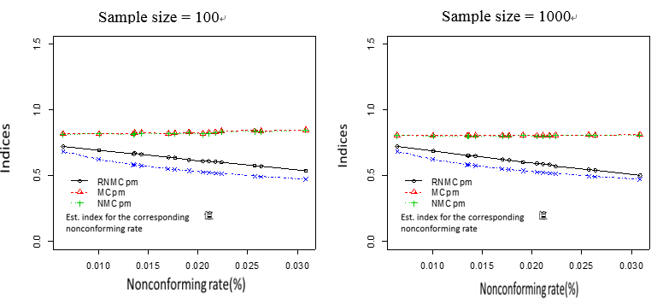

Figure 5. Comparison of simulation results for various *MPCpm* indices with different non-conforming rates under Combined Gamma-Beta distributions (when one process mean > target value, the other process mean < target value)

***4.3.　Summary of the comparison results for Evaluation Criterion (2)***

5000 simulations were run and summarized in tables. Simulation procedure is listed below:

1. Use copula functions to generate bivariate Gamma (16/9,4) distributions as well as

Gamma (16/9, 4/3) and Beta (8,0.923) combined distributions; we take random samples with n= 100, 500 and 1000.

1. Assume the overall non-conforming rates of two multivariate processes *p*=0.27% or

1%, we first set their *USL* and *LSL*. Then use the above sampling information to calculate *MCp*, *NMCp*, and *RNMCp*as well as *MCpm*, *NMCpm*, and *RNMCpm* indices with three different target values, as shown in Equation (19).

1. Use simulation method to obtain the actual non-conforming rate values for different

cases as shown in Table 2, 3and 4 and then estimate their corresponding index values. Finally, we obtain their MAPE and MSE values to assess the accuracy of various multivariate process capability indices.

1. Summarize the MAPE and MSE values in tables to compare the differences among

various multivariate process capability indices.

Table 2. Comparison of MSE and MAPE for various indices under Bivariate Gamma distributions and Combined Gamma-Beta distributions (when process means= target values and sample size n=1000)

|  |  |  |  |  |  |  |  |  |
| --- | --- | --- | --- | --- | --- | --- | --- | --- |
| Distribution | *p* | *MSE*(n=1000) | | |  | *MAPE*(n=1000) | | |
|  |  |  |  |  |  |  |
| Gamma(1.778,1.333)  & Gamma(1.778,1.333) | 0.27% | 0.0038 | 0.1260 | 0.1231 |  | 7.59% | 53.41% | 52.79% |
| 1% | 0.0022 | 0.0453 | 0.0440 |  | 6.70% | 36.25% | 35.70% |
| Gamma(1.778 , 1.333)  & Beta(8,0.923) | 0.27% | 0.0023 | 0.1271 | 0.1232 |  | 5.83% | 53.85% | 52.99% |
| 1% | 0.0028 | 0.0476 | 0.0963 |  | 7.97% | 37.63% | 36.87% |

Table 2 indicates that the *RNMCp* outperforms the other multivariate indices in terms of accuracy when quality characteristics follow a Bivariate Gamma or combined Gamma-Beta distributions since both MSE and MAPE values of *RNMCp* index are the smallest ones among various indices.

Table 3. Comparison of MSE and MAPE for various indices under Bivariate Gamma distributions and Combined Gamma-Beta distributions (when one process mean > target value, the other process mean < target)

|  |  |  |  |  |  |  |  |  |  |  |
| --- | --- | --- | --- | --- | --- | --- | --- | --- | --- | --- |
| Distribution | *p* | *MSE*(n=1000) | | |  | | | *MAPE*(n=1000) | | |
|  |  |  | |  |  | |  |  | |
| Gamma(1.778,1.333)  & Gamma(1.778,1.333) | 0.27% | 0.0056 | 0.0811 | 0.0793 | |  | 12.85% | | 53.60% | 52.98% | |
| 1% | 0.0007 | 0.0291 | 0.0282 | |  | 4.47% | | 36.39% | 35.84% | |
| Gamma(1.778 , 1.333)  & Beta(8,0.923) | 0.27% | 0.0034 | 0.0795 | 0.0770 | |  | 9.91% | | 53.40% | 52.55% | |
| 1% | 0.0005 | 0.0294 | 0.0283 | |  | 4.09% | | 37.23% | 36.47% | |

Table 4. Comparison of MSE and MAPE for *RNMCpu* index with two components under Gamma(1.778 , 1.33) distribution (when one process mean > target value, the other process mean < target value; n=1000)

|  |  |  |  |  |  |  |
| --- | --- | --- | --- | --- | --- | --- |
|  | *p* | *MSE*(n=1000) | |  | *MAPE*(n=1000) | |
|  |  |  |  |  |
| The first component | 0.27% | 0.0042 | 0.0447 |  | 7.01% | 27.25% |
| 1% | 0.0040 | 0.0450 |  | 6.87% | 27.35% |
| The second component | 0.27% | 0.0014 | 0.0178 |  | 4.42% | 18.62% |
| 1% | 0.0014 | 0.0180 |  | 4.43% | 18.72% |

To assess the accuracy of *RNMCpm* under the condition when one process mean is greater than the target value and the other process mean is smaller than the target value, Table 3 indicates that *RNMCpm* outperforms the other multivariate indices in terms of accuracy when quality characteristics follow Bivariate Gamma or combined Gamma-Beta distributions since both MSE and MAPE values of *RNMCpm* index are the smallest ones among various indices.

Similarly, criterion (2) can be used to compare the accuracy of *RNMCpu* and *ND* indicesfor the-smaller-the-better case. Since “left skewed” distributions with abnormally high non-conforming rate are rarely occurred for the-smaller-the-better case, only the bivariate Gamma combined distributions was considered by taking random samples with sample sizes, n= 100, 500 and 1000. Note that *ND* is a 2 × 1 matrix in which the first component represents process capability for the first quality characteristic and the second component represents the process capability for the second quality characteristic. Assuming the overall non-conforming rates of two multivariate processes *p* = 0.27% or 1%, Table 4 indicates that both MSE and MAPE values for *RNMCpu* index are smaller than *ND* with respect to the two components under bivariate Gamma(1.778 , 1.33) distribution when one process mean is greater than target value and the other process mean is less than target value. Therefore, the actual non-conforming rates for the non-normal data can be properly reflected by the proposed *RNMCp*, *RNMCpm* and *RNMCpu* indices regardless of the process mean hitting the target or not.

**5.　Numerical Example**

To demonstrate the practical application of the proposed indices, process data provided by Wang [13]was used, where *X*1、*X*2、*X*3 are three key characteristics of a connector that is used by a desk computer manufacturer. The target values and their corresponding upper and lower specification limits (*USL, LSL*) are listed in Table 5.

Table 5. The target values, USL and LSL for the three characteristics, Wang [13]

|  |  |  |  |
| --- | --- | --- | --- |
| Characteristics | Target Values | *USL* | *LSL* |
| X1 | 0.10 | 0.06 | 0.14 |
| X2 | 0.07 | 0.02 | 0.12 |
| X3 | 0.07 | 0.02 | 0.12 |

After collecting 100 random samples, a Multivariate Shapiro-Wilk test is used to check for normality with p-value = 0.00005. This is far smaller than the critical α assumed at the significance level = 0.05 , which implies that this process data set does not follow a multivariate normal distribution since the null hypothesis is that the distribution is normal and the p-value << α .

Listed below is the procedure for calculating two non-normal multivariate process capability indices (*RNMCp*, *RNMCpm*) for the-nominal-the-better case:

1. Use the process mean of each quality characteristic as a dividing point to partition

the entire process into different regions. Then using the multivariate WSD method the variance-covariance matrix of each region is adjusted.

1. Estimate the volume for each of revised region using the adjusted

variance-covariance matrixes.

1. Calculate *RNMCp* by taking the minimum ratio in Equation (14), in which the ratio

is the volume of engineering tolerance region divided by the volume of revised process region.



1. Calculate *RNMCpm*as shown in Equation (15), in which *RNMCpm* is *NMCp* divided

by a correction factor *DW*=1.876.



Following the above procedure, the estimated values of the multivariate process capability indices are obtained: *NMCp* =1.002, *NMCpm*= 0.521, *RNMCp* =0.799 and *RNMCpm*= 0.426. Since one data point in the first characteristic *X*1= 0.1414 exceeds its USL, the multivariate process capability, *MPCp* , should result in a value less than 1. Contrast this with *NMCp* value = 1.002 whereas the new *RNMCp* and *RNMCpm* indices are less than 1, which reflect the actual performance of this multivariate manufacturing process. This numerical example further shows that the actual quality performance of a non-normal multivariate process can be properly reflected by the proposed capability indices.

**6.　Conclusions and Future Research Areas**

In this paper, we propose three non-normal multivariate process capability indices, *RNMCp* , *RNMCpm* and *RNMCpu* by relieving the normality assumption. Based on the two normal multivariate process capability indices proposed by Pan and Lee [1], a multivariate weighted standard deviation method (MWSD) was used to modify *NMCp* and *NMCpm* indices for the-nominal-the-best case. The MWSD method is also applied to modify the multivariate process capability index, ND Index, by Niverthi and Dey [2] for the-smaller-the-better case.

In addition, we conduct simulation studies to compare the performance among various multivariate process capability indices. Simulation results show that the actual non-conforming rates can be correctly reflected by the proposed indices, which are more suitable to measure the quality performance of multivariate processes under different combinations of two skewed distributions than the previous *MCp*, *MCpm*, *NMCp*, *NMCpm* and *ND* indices. Finally, a numerical example further demonstrates the usefulness of the proposed capability indices.

This paper provides practicing managers and engineers with an accurate statistical process control tool for correctly measuring the performance of any multivariate manufacturing product or environmental system. Once the existing multivariate quality/environmental problems and their Key Performance Indicators (KPI) are identified, one may apply the new capability indices to evaluate the performance of various multivariate processes subject to non-normal distributions.

The contributions and future research areas of this research are summarized as follows:

1. Two new non-normal multivariate process capability indices *RNMCp*and *RNMCpm*

for the nominal-the-best case. The new indices accurately reflect the actual performance for a non-normal multivariate process.

1. For the-smaller-the-better case, a MWSD method is used to modify the *ND* Index

and a new non-normal multivariate process capability index *RNMCpu* is derived. The new index more accurately reflects the actual process performance。

1. The numerical example demonstrates that the actual quality performance of a

multivariate manufacturing process can be determined by the proposed non-normal multivariate process capability indices,*RNMCp* and *RNMCpm***.**

1. The statistical properties of these non-normal multivariate process capability

indices need to be studied further in future research.

1. Similar research can be extended to develop non-normal multivariate process

capability indices for dependent data.

References

1. Pan JN, Lee CY, *New capability indices for evaluating the performance of multivariate manufacturing processes.* Quality and Reliability Engineering International,26(1) (2010), pp. 3-15.
2. Niverthi M, Dey DK *Multivariate process capability, a Bayesian perspective.* Technical Report, Dept. of Statistics, University of Connecticut, Storrs. (1995)
3. Hubele NF, Shahriari H, Cheng CS, *A bivariate process of capability vector in statistics process control in manufacturing edited by J. B. Keats, and D. C. Montgomery.* Marcel Dekker, NY, (1991), pp. 299-310.
4. Taam W, Subbaiah P, Liddy JW, *A note on multivariate capability indices.* Journal of Applied Statistics, 20(3) (1993), pp. 339-351.
5. Corbett CJ, Pan JN, *Evaluating environmental performance using statistical process control techniques.* European Journal of Operational Research, 139 (2002), pp. 68- 83.
6. Juran JM, *Quality Control Handbook*, McGraw-Hill, New York. (1974).
7. Kane VE, *Process Capability Indices*. Journal of Quality Technology, 18(1) (1986), pp. 41-52.
8. Chan LK, Cheng SW, Spiring FA, *A new measure of process capability: Cpm*. Journal of Quality Technology, 20(3) (1988), pp. 162-175.
9. Pearn WL, Kotz S and Johnson NL, *Distributional and inferential properties of process capability indices.* Journal of Quality Technology, 24(4) (1992), pp. 216-231.
10. Wu H, Swain J, Farrington P, Messimer S, *A weighted variance capability index for general non-normal processes*. Quality and reliability engineering International, 15(5) (1999), pp. 397-402.
11. Chang YS, Choi I, Bai DS, *Process capability indices for skewed populations*. Quality and Reliability Engineering International, 18(5) (2002), pp. 383-393.
12. Chang YS, Bai DS, *A multivariate control chart for skewed populations using weighted standard deviations*. Quality and Reliability Engineering International, 20(1) (2004), pp. 31-46.
13. Wang FK, *Quality evaluation of a manufactured product with multiple characteristics*. Quality and Reliability Engineering International, 22(2) (2006), pp. 225-236.